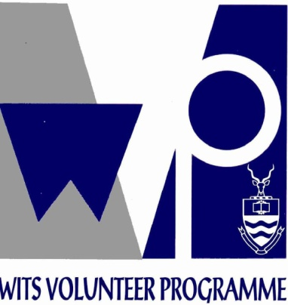 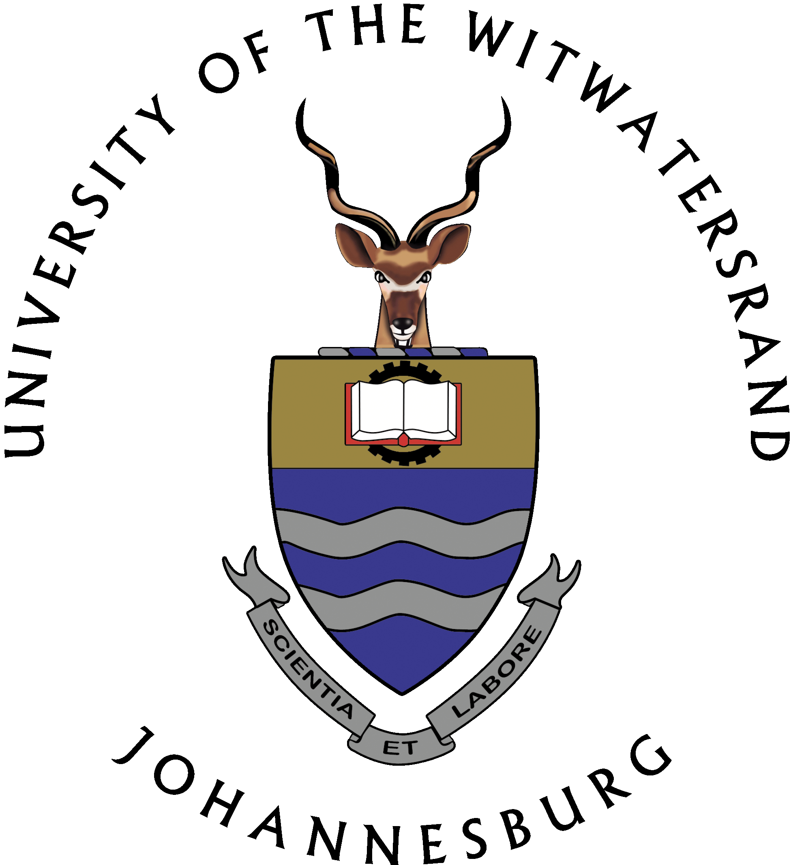 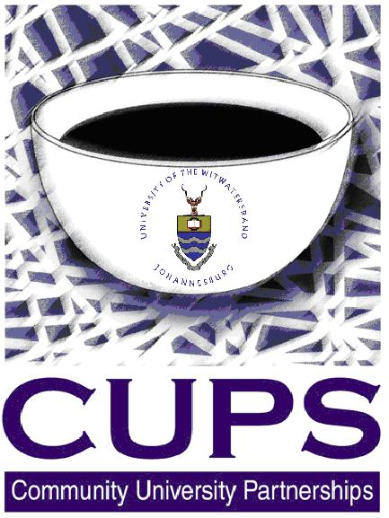

COLLOQUIUM PROGRAMME

“Strengthening Community Development through Collaboration”

University of Witwatersrand CB8 – Friday, 12 August 2011

8H30 Welcome Tea/Coffee

9H00 Welcome and Introduction Prof Y Ballim

9H30 Community Engagement at Wits Dr M Moolla (CUPS)

9H45 “CE is not a one-way street: Prof M Rudolf – Community Dentistry

Lessons learned from the Siyakhana Ms M Beery

Initiative for Ecological Health and

Food Security”

10H00 “Taking Oral Health Services to Dr M Molete – Community

Communities” Dentistry

10H15 “A Thinking Village” Prof K Murris –Philosophy of Education

10H30 “The politics of CE – the case of Dr C Benit-Gbaffou- Architecture &

Yeoville Studio” Planning

10H45 “A Social Ecological model for CE” Ms M Hlungwani - Graduate Entry

Medical Programme.

11H00 “Go to University to Succeed” Mr L Mashiloane – SETMU

11H15 Tea/Networking

11H30 “Multidisciplinary approach to CE Mrs A Mapuwose – Humanities and

interests in the School of Human and Community Development

and Community Development “.

11H45 “Engineers Without Borders “ Mr R Louw - PhD (Eng) Chemical (Candidate)

12H00 “Preparing for the World” Ms K Singh – WVP

Mr Z Nhlapo - WVP

12H15 Lunch/Networking

13H00 Roundtable discussion on opportunities for collaboration

15H00 Programme ends